Graph Visualisation Tools User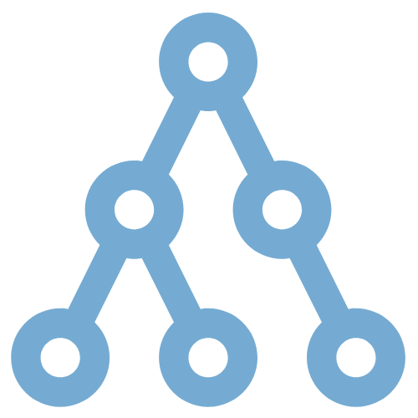 Guide

<https://github.com/HamadTria/Network-Tools>

1. Introduction 2

Overview of Features 2

Key Functionalities 2

Getting Started 2

1. Homepage 3

Navigation Bar 3

Sigma.js Section 3

Cytoscape Section 3

1. Cytoscape Page 4

Control Panel 4

Graph Visualization Area 4

Interactive Features 5

1. Context Menu Page 6

Large Cytoscape Graph 6

Small Cytoscape Graph 6

Interactive Features 6

1. Multi-Mode Page 8

Multi-Mode Graph 8

Filter-Mode Graph 8

One-Mode Graph 9

Interactive Features 9

1. Big Data Network Page 10

Interactive Features 10

# Introduction

Welcome to the Graph Visualization Tools User Guide. This guide is designed to help you navigate and utilize features of our graph visualization application. Whether you are analyzing complex networks or exploring large datasets, this tools provide an intuitive way to visualize, interact with, and gain insights from data.

## Overview of Features

This application includes several key pages, each designed to cater to different aspects of graph visualization. The two main pages are the Multimode Page and the Big Data Network Page.

1. Multimode Page

* The Multimode page allows users to visualize and analyze multimodal networks, where nodes and edges can represent different types of entities and relationships. This page provides customizable layout options, filtering capabilities, and interactive elements to help users explore complex networks in a more manageable way.

1. Big Data Network Page

* The Big Data Network page is designed to visualize large-scale networks. It offers layout algorithms, interactive filtering, and context menu options for nodes and edges. This page demonstrates that even with vast amounts of data, users can efficiently navigate and extract meaningful patterns from their networks.

## Key Functionalities

1. Customizable Layouts

Each page provides multiple layout options to help you organize and display your network data in the most insightful way. You can switch between layouts like Circle, Grid, Concentric, and more to find the one that best fits your analysis needs.

1. Interactive Filtering

Filter nodes and edges based on specific criteria to focus on the most relevant parts of your network. This functionality is particularly useful when dealing with large and complex datasets, allowing you to isolate and examine sub-networks in detail.

1. Contextual Menus

Right-click context menus offer quick actions for nodes and edges, such as resizing, isolating, changing shapes, and marking. These features enhance your ability to interact with and manipulate the graph directly.

1. Downloadable Visualizations

Easily export your visualizations as images for reports, presentations, or further analysis. This feature ensures that you can share your insights and visualizations with others effectively.

## Getting Started

To get started, simply navigate to the desired page via the application's navigation bar. Each page is equipped with user-friendly controls and options to help you tailor the visualization to your specific needs. As you explore the features, refer to this guide for detailed instructions and tips on how to make the most out of each tool.

# Homepage

The homepage of the Graph Visualisation Tools app provides an introduction to two graph visualisation libraries, Sigma.js and Cytoscape and allows users to navigate to different sections of the app. Below is a detailed description of each component on the homepage.

## Navigation Bar

The navigation bar at the top of the page provides quick links to different app sections.

The navigation bar is visible on all pages of the app.

1. Logo and Title

On the left side, you'll see the app's logo and title, "Graph Visualisation Tools". These elements are clickable and they take you back to the homepage.

1. Menu Dropdown

On the right side, there is a dropdown menu with links to the Home, Compare, Cytoscape, Sigma, Context-menu, Mode transformation,  and Big Data Network pages.



Navigation Bar

## Sigma.js Section

The Sigma.js section introduces the library, highlighting its key features, advantages, and disadvantages. This section is presented in a card format with a Card Header and a Card Body. The card is clickable and takes you to the Sigma.js page.

Note that during the building of this app, very little development was made using the Sigma.js library as more time was allocated to the discovery of Cytoscape.

## Cytoscape Section

Similarly to the previous section, the Cytoscape section introduces the library, providing an overview of its capabilities, advantages, and disadvantages. This section is also presented in a card format with a Card Header and a Card Body. The card is clickable and takes you to the Cytoscape page.

# Cytoscape Page

The Cytoscape page in the Graph Visualization Tools app provides users with an interactive environment to visualize and manipulate network graphs using the Cytoscape.js library. The graph uses a criminal dataset publicly available on the following [Zenodo page](https://zenodo.org/records/10956763).

The main content of the Cytoscape page consists of an interactive graph visualization area and a control panel.

Below is a detailed description of each component on the Cytoscape page.

## Control Panel

The control panel allows users to select the layout of the graph and choose the expansion mode.

1. Layout Dropdown

Allows users to select from various graph layout options such as random, grid, circle, concentric, breadthfirst, cose, cose-bilkent, dagre, cola, klay, spread, and euler.

1. Expand Options

Users can choose to expand the graph by either followers or following nodes.

## Graph Visualization Area

The graph visualization area displays the network graph based on the selected layout and expansion mode.

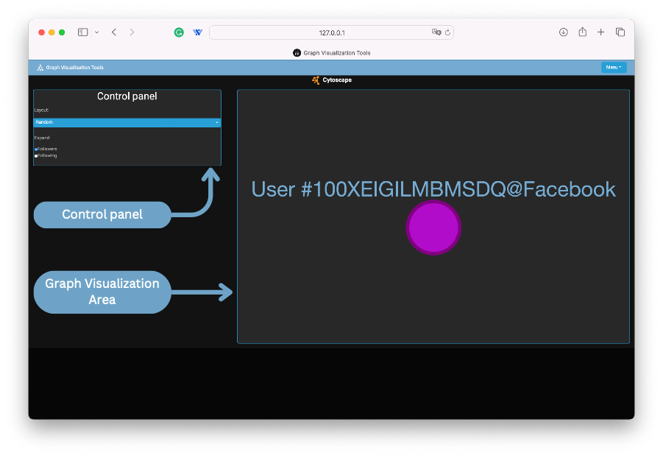

## Interactive Features

1. Expanding Nodes

By clicking on a node, users can expand it to show its followers or following nodes based on the selected expansion mode.

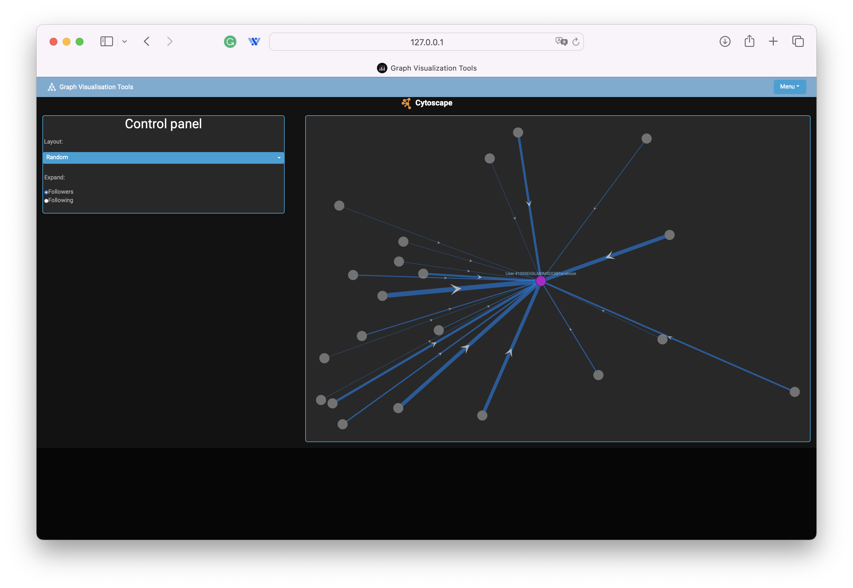

After clicking on node

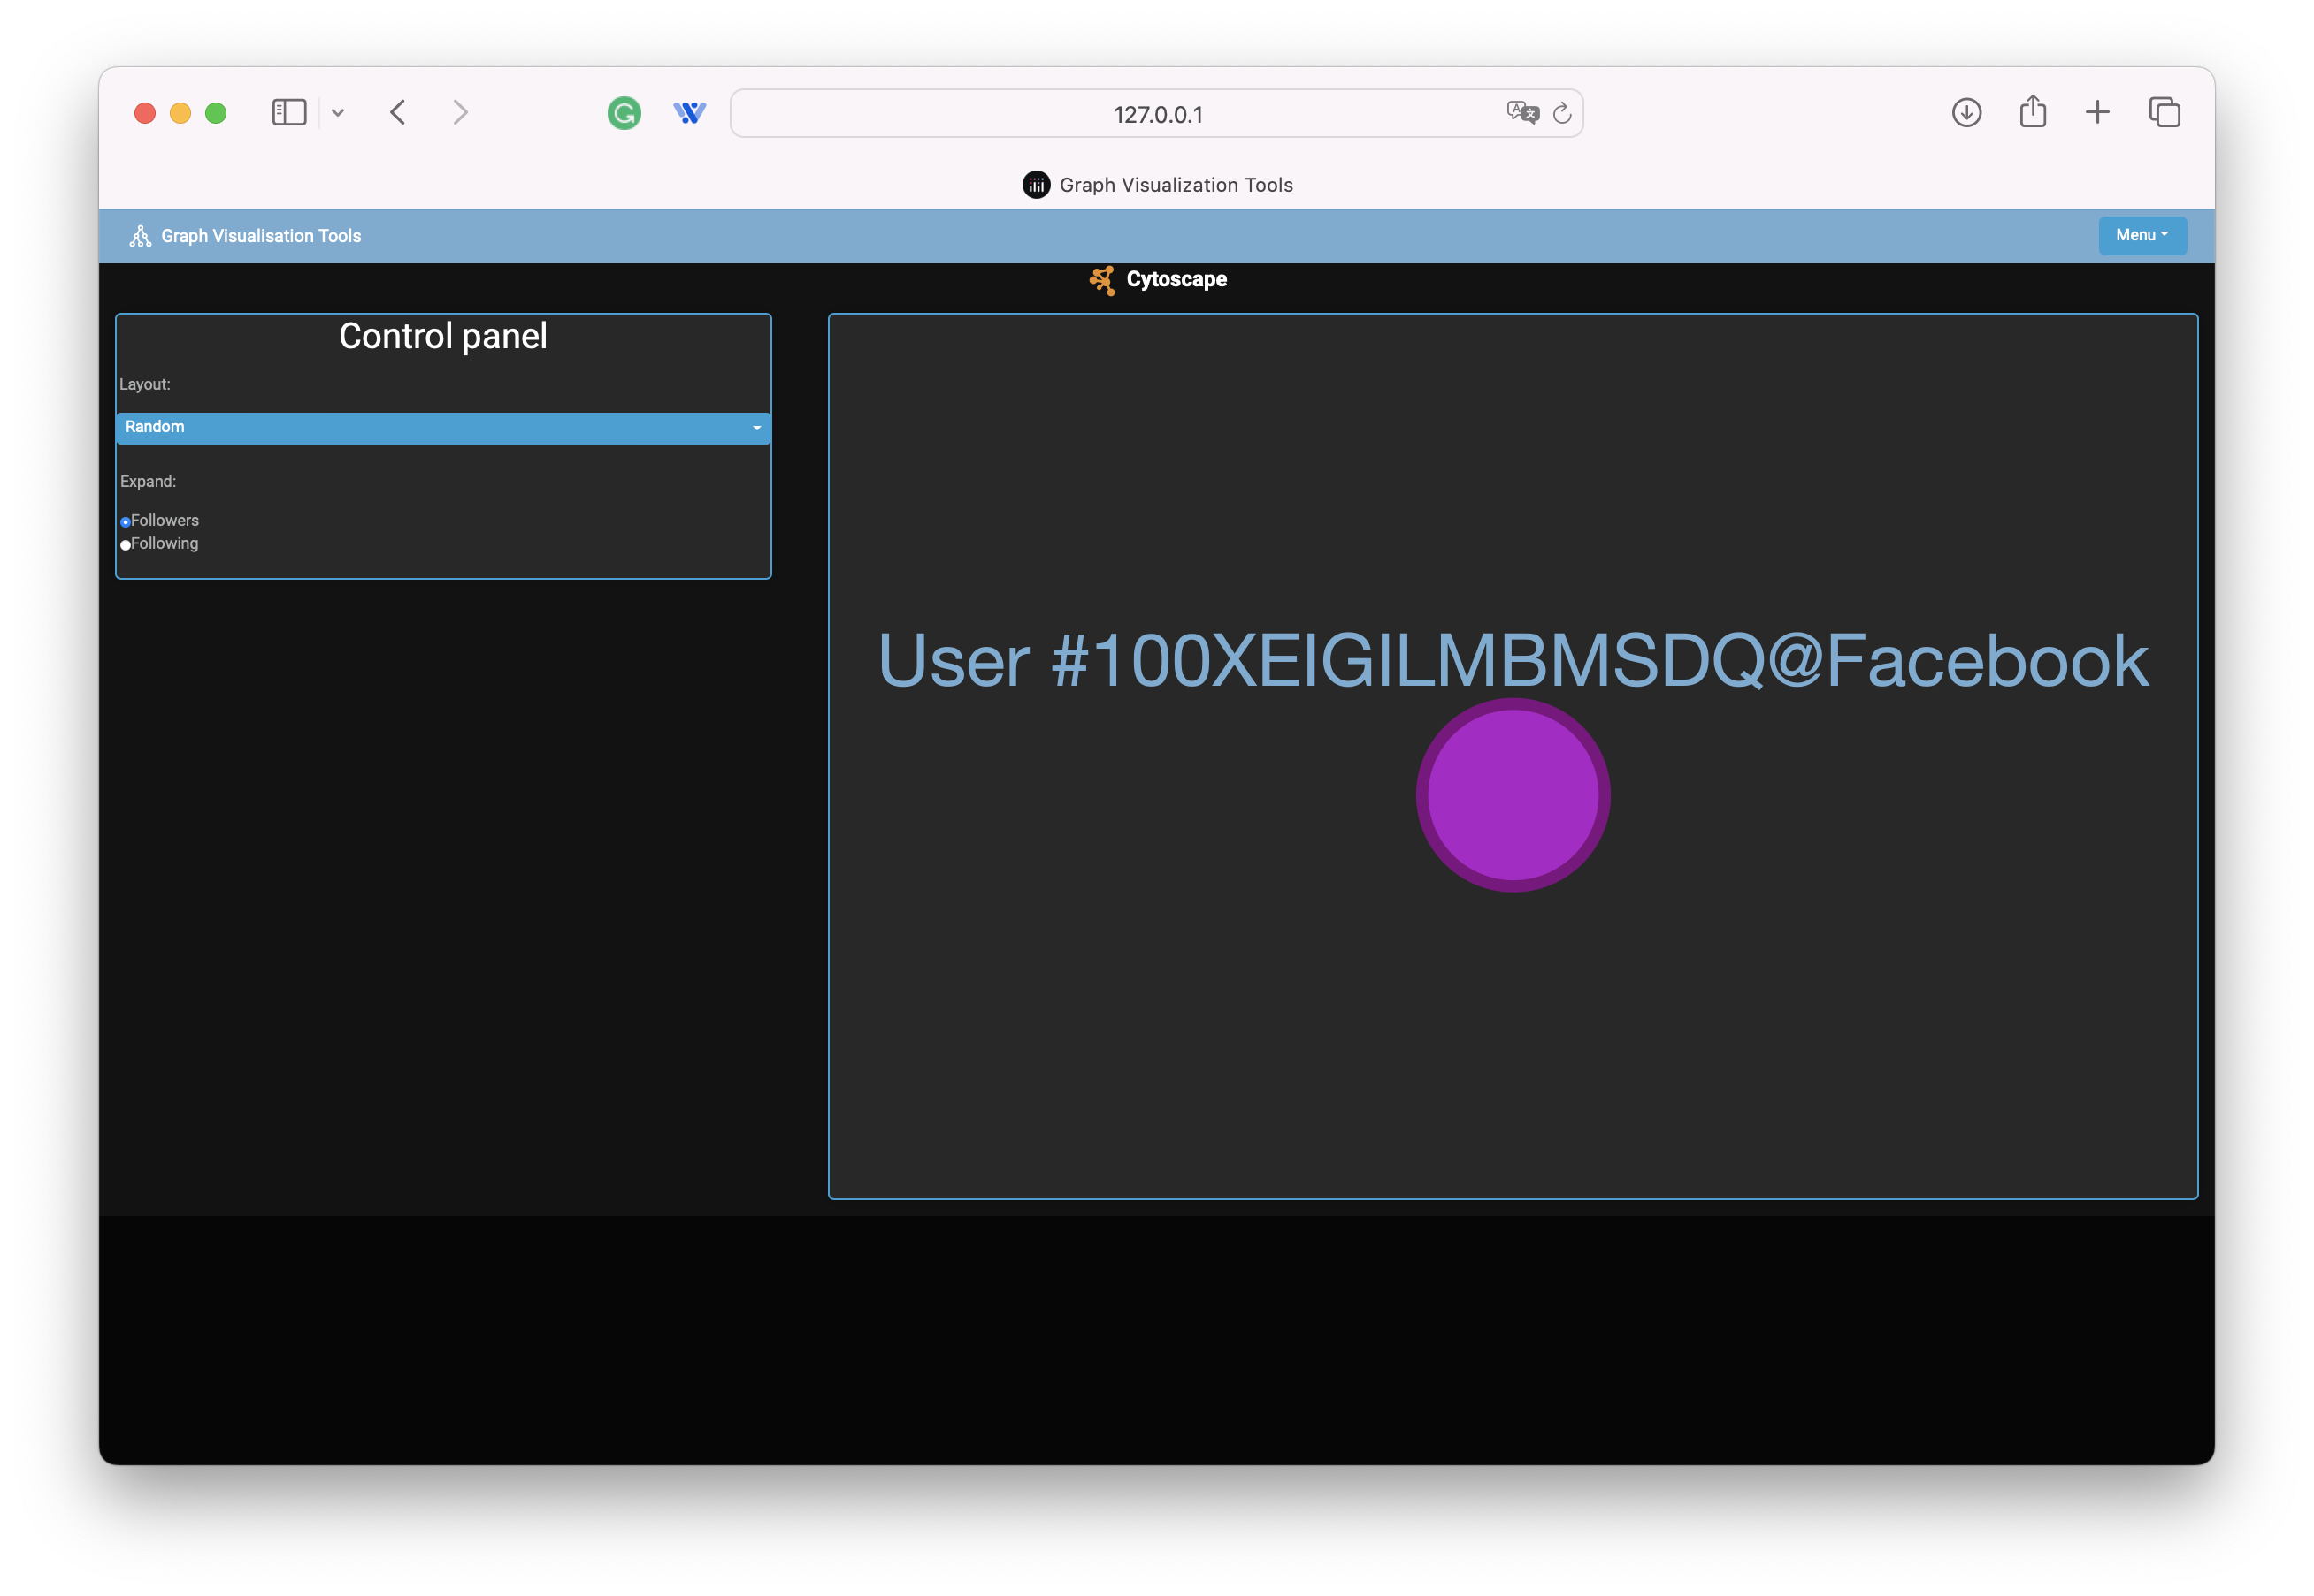

Before clicking on node

# Context Menu Page

The Context Menu page in the Graph Visualization Tools app demonstrates the interactive capabilities of context menus within a Cytoscape.js graph.

The main content of the Context Menu page consists of a large Cytoscape graph and a smaller Cytoscape graph, both demonstrating the use of context menus.

## Large Cytoscape Graph

The large Cytoscape graph is displayed in the main area and supports various context menu actions. Users can interact with nodes and edges through a right-click context menu that provides multiple commands.

## Small Cytoscape Graph

A smaller Cytoscape graph is displayed on a card on the right side. This smaller graph mirrors the elements of the large graph and updates in response to interactions made in the larger graph.

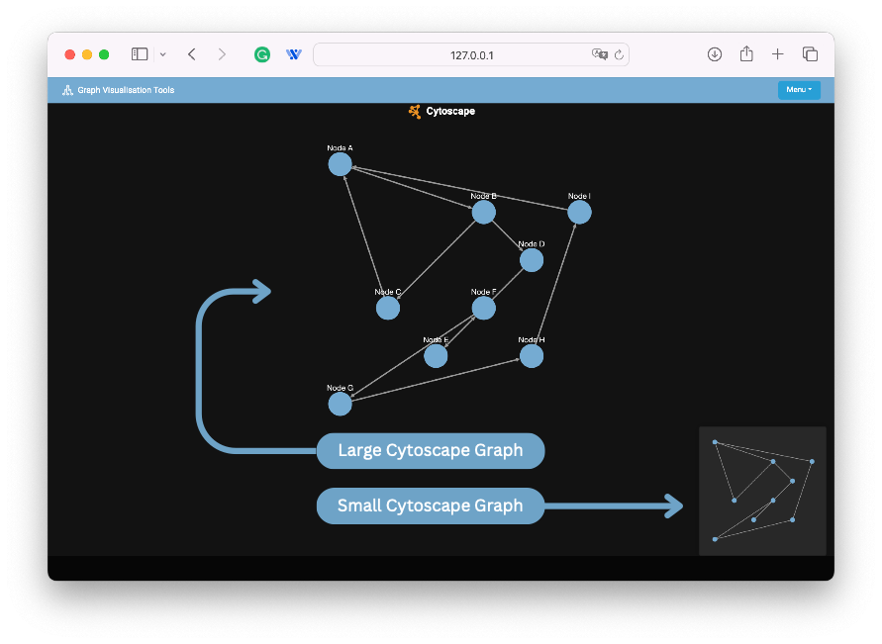

## Interactive Features

The Context Menu page includes several interactive features accessible through right-click context menus on nodes, edges, and the graph canvas.

1. Node and Edge Context Menu

Right-clicking on a node or edge opens a context menu with the following options:

* **Change Size**: Toggles the size of the node between small and large.
* **Isolate Node**: Isolates the selected node by hiding all other nodes and edges. Clicking again restores the visibility of all elements.
* **Change Shape**: Toggles the shape of the node between an ellipse and a square.
* **Mark Node**: Toggles the color of the node between red and the default blue.
* **Delete**: Hides the selected node or edge.

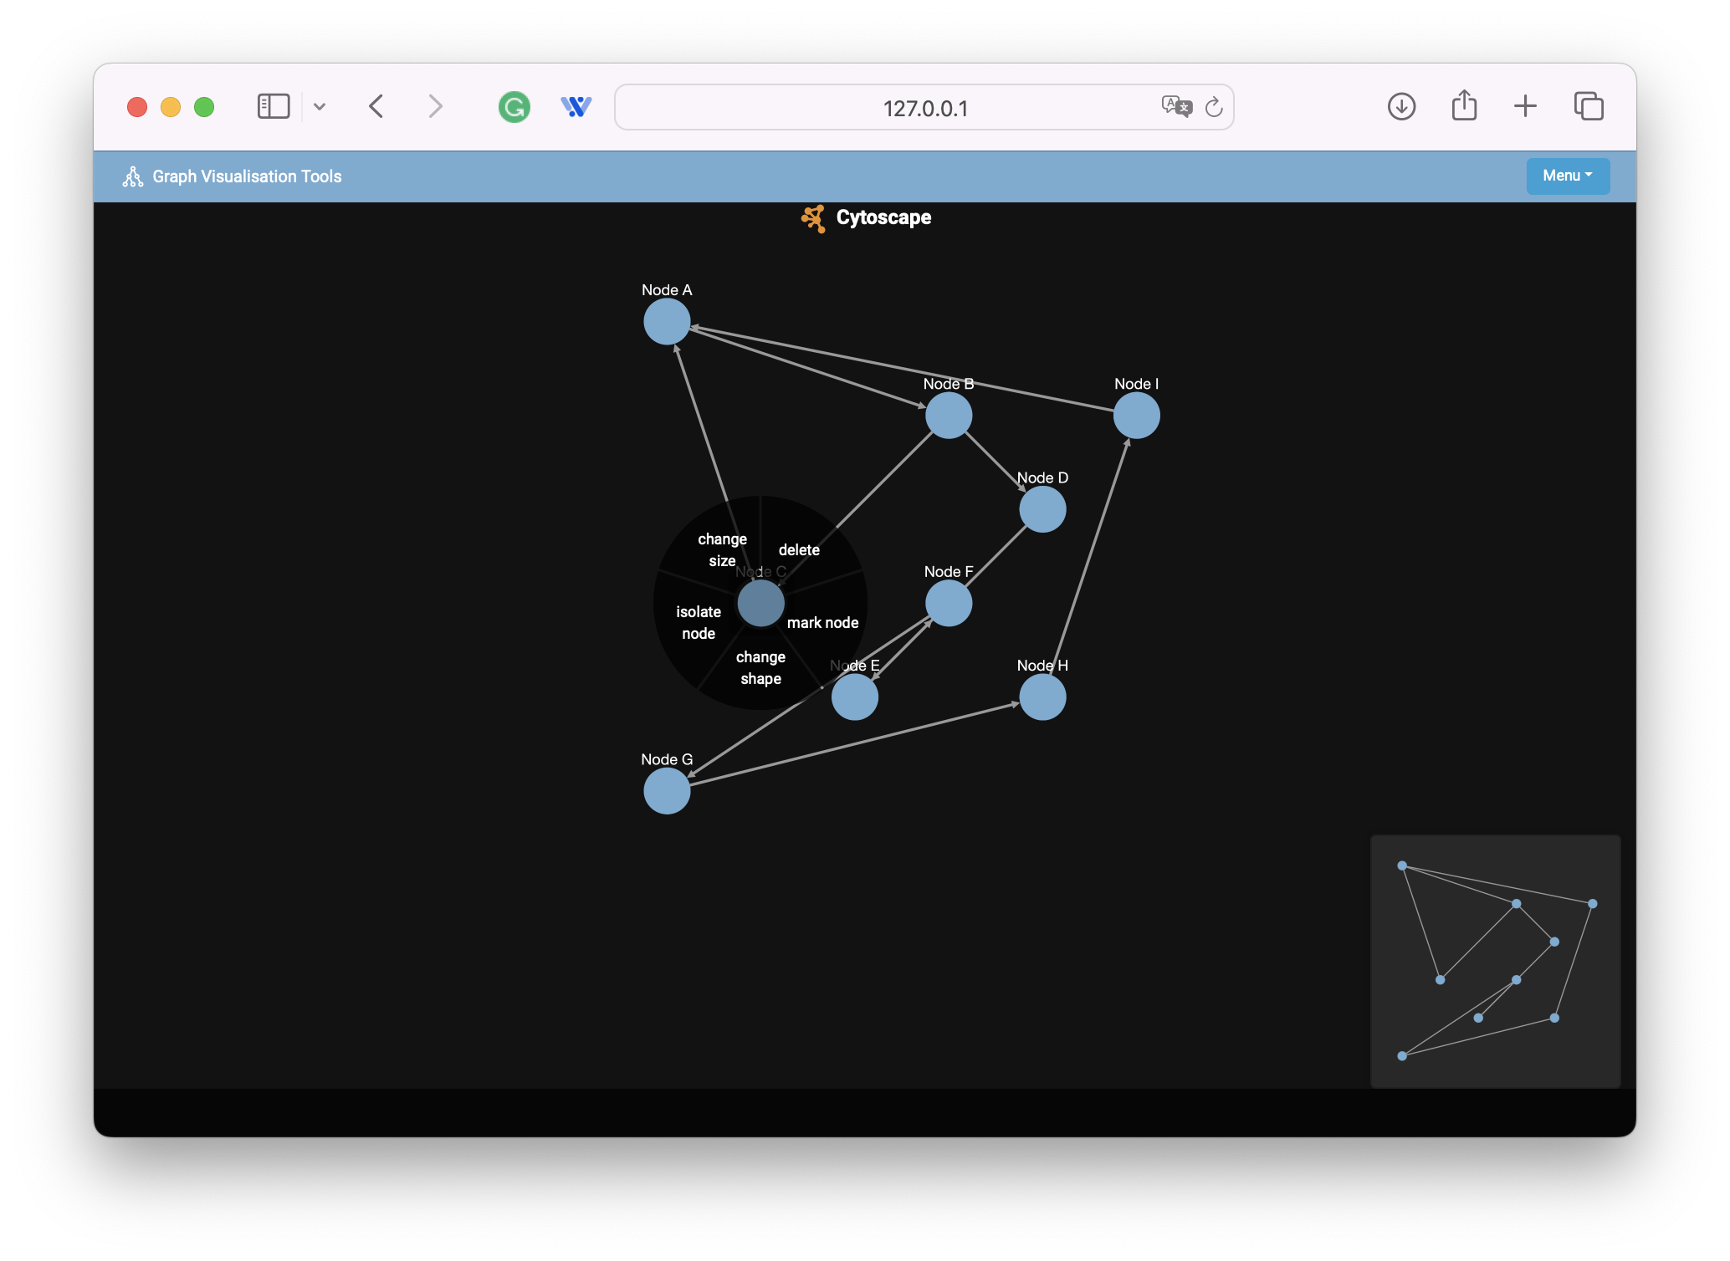

Right click on node

1. Canvas Context Menu

Right-clicking on the canvas opens a context menu with the following options:

* **Background 1**: Changes the background color of all nodes to the default blue.
* **Background 2**: Changes the background color of all nodes to a pinkish color.
* **Bring Back Nodes**: Restores the visibility of all hidden nodes and edges.

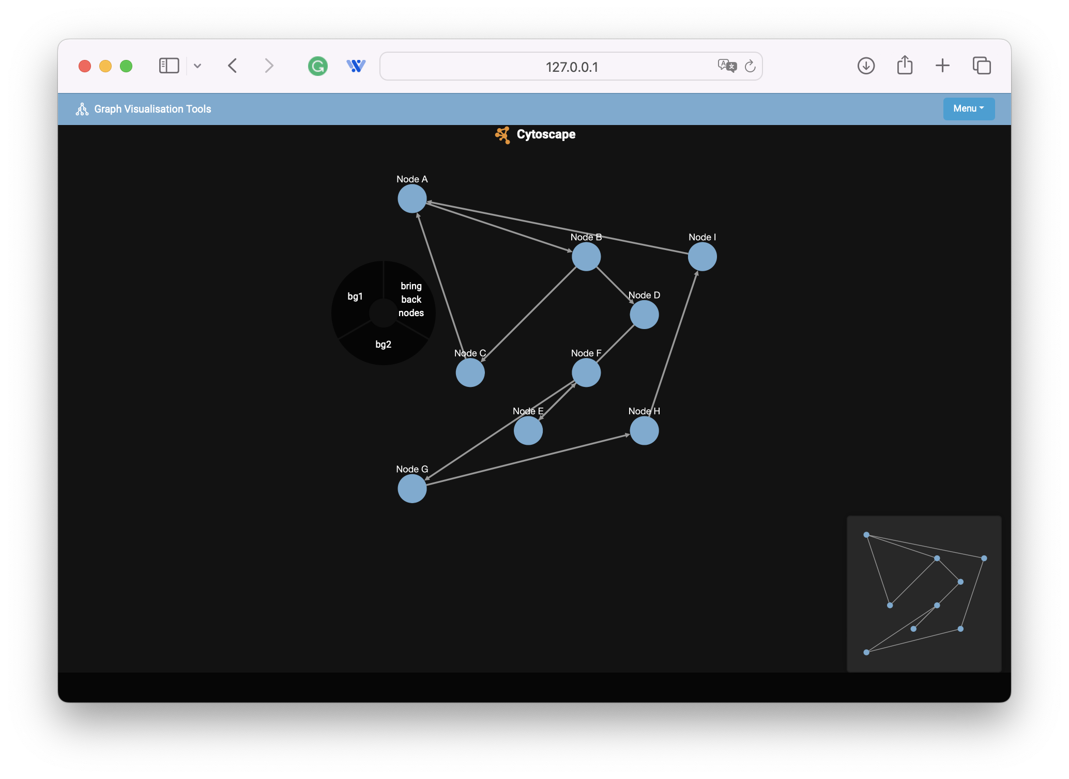

Right click on canvas

# Multi-Mode Page

The Multi-Mode Page provides a sophisticated visualization of complex networks through three synchronized graph views: Multi-Mode Graph, One-Mode Graph, and Filter-Mode Graph. This setup allows for comprehensive exploration and analysis of various types of nodes and their relationships.

This page offers three distinct types of graphs, each designed to provide unique insights and perspectives. Here is an overview description of each graph:

## Multi-Mode Graph

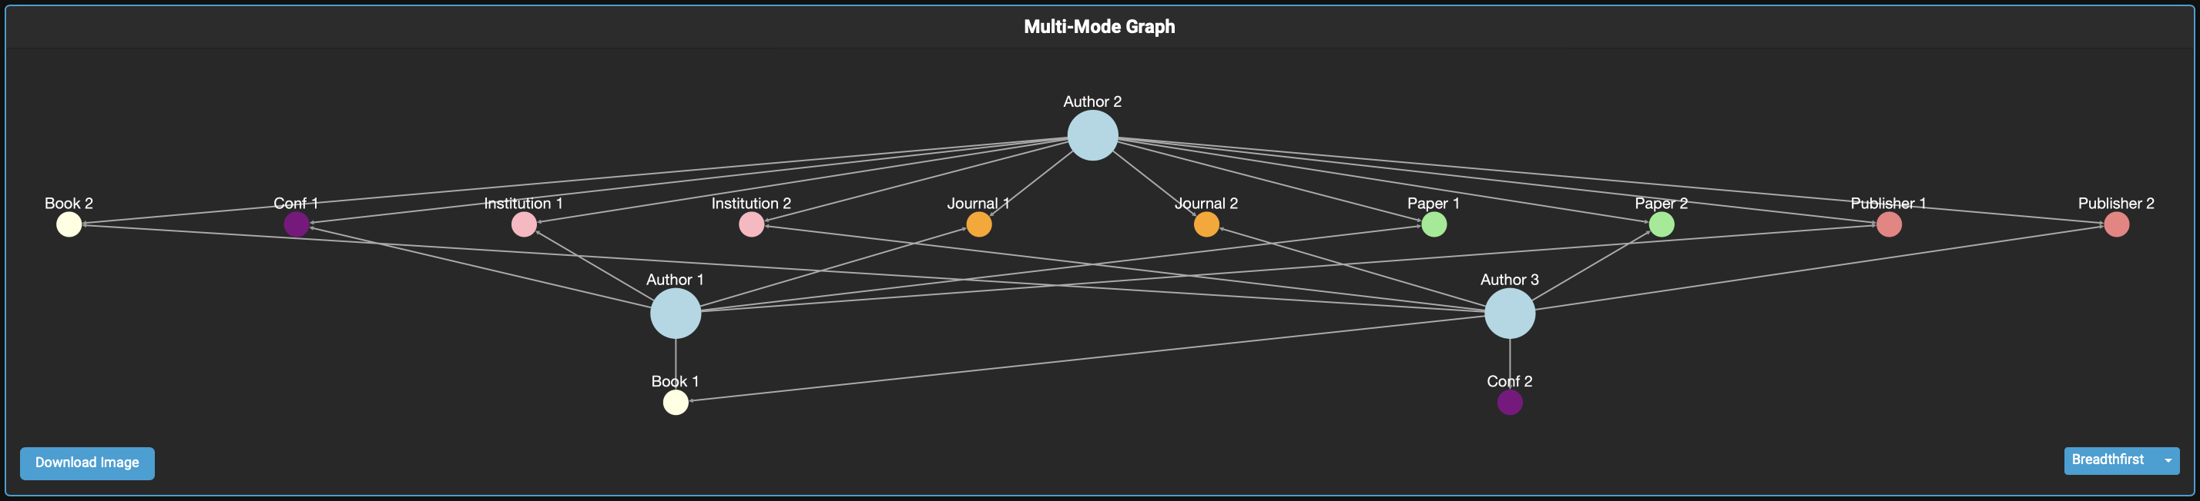The Main Multimode Graph is the central feature of the Multimode page. This graph visualizes the entire network, displaying nodes and edges of various types. It is designed to provide a comprehensive view of the relationships and connections within your dataset.

## Filter-Mode Graph

This graph allows users to focus on specific parts of the network by applying a filter using the dropdown menu. This graph helps in isolating and examining subsets of the network based on selected modes (i.e. node types)

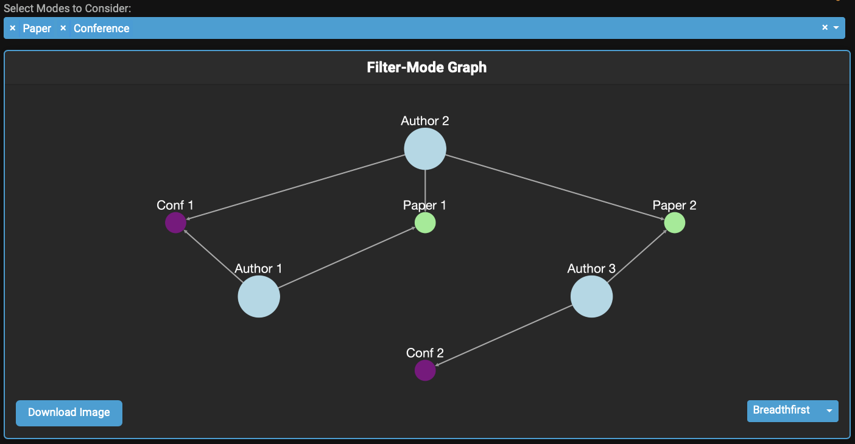

## One-Mode Graph

This graph provides a high-level summary of the network's properties. It highlights the overall structure and connections between individuals (authors).

In the multi-mode graph, there are multiple types of nodes and relationships between them. The one-mode graph focuses on a single type of node (the target mode) and simplifies the network by representing indirect connections through other types of nodes.

The edges can be weighted to indicate the strength or number of shared connections. In the example of authors and papers, the weight of the edge between two authors might represent the number of papers they have co-authored and the number of conferences they attended together.

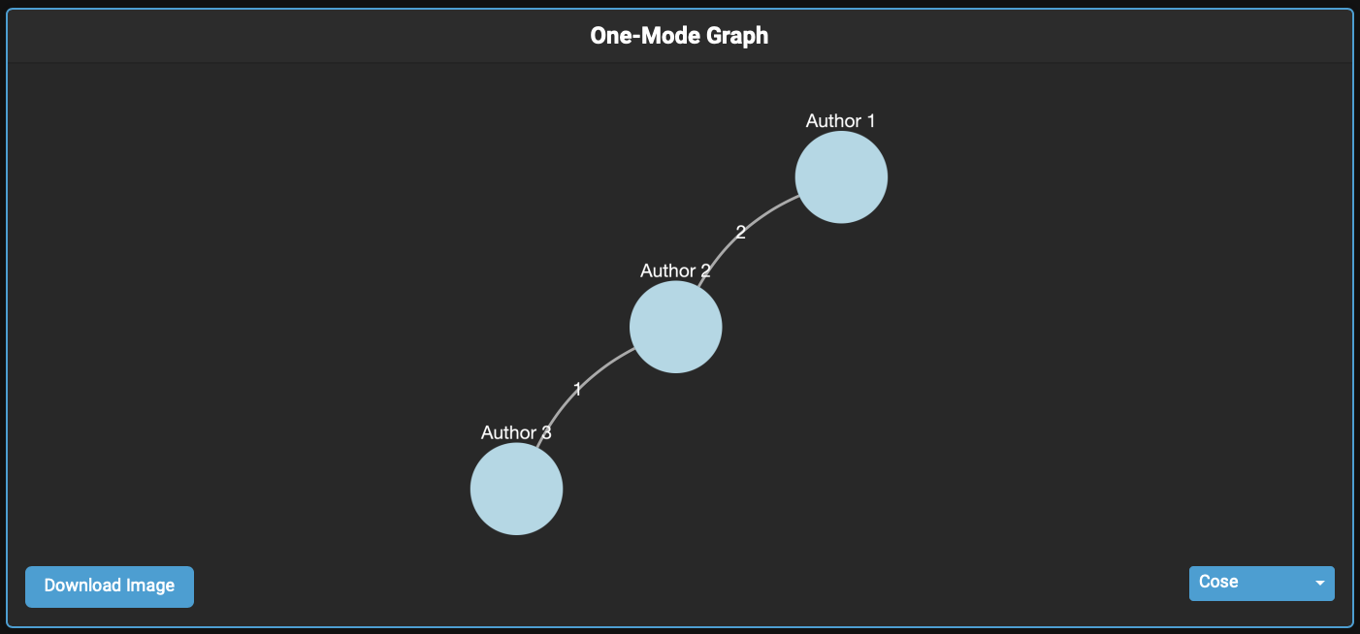

By transforming a multi-mode network into a one-mode graph, we can gain valuable insights into the structure and dynamics of the relationships within a specific set of nodes, facilitating targeted analyses and decision-making.

## Interactive Features

1. Utilizing Context Menus

Right-click on nodes or edges to access context menus. Use these options to manipulate the visualization, such as isolating nodes, changing shapes, or marking nodes for emphasis.

1. Analyzing Relationships

Leverage synchronized selection to trace connections across different modes. Selection in one graph highlights related nodes and edges in the other graphs, giving a comprehensive view of the network.

1. Exploring the Graphs

Use the synchronized views to explore different aspects of the dataset. The multi-mode graph offers an overall view, the one-mode graph focuses on author-specific relationships, and the filter-mode graph provides a refined analysis.

# Big Data Network Page

The Big Data Network Page provides an example tool for visualizing and interacting with large-scale network data using the Cytoscape library.

Similarly to the Cytoscape page, the graph uses a criminal dataset publicly available on the following [Zenodo page](https://zenodo.org/records/10956763).

Like the other pages in this app, It includes options for layout configurations, data filtering, and various context menu actions for enhanced data analysis.

## Interactive Features

1. Adjusting Layout

Use the layout dropdown to reorganize the graph based on different algorit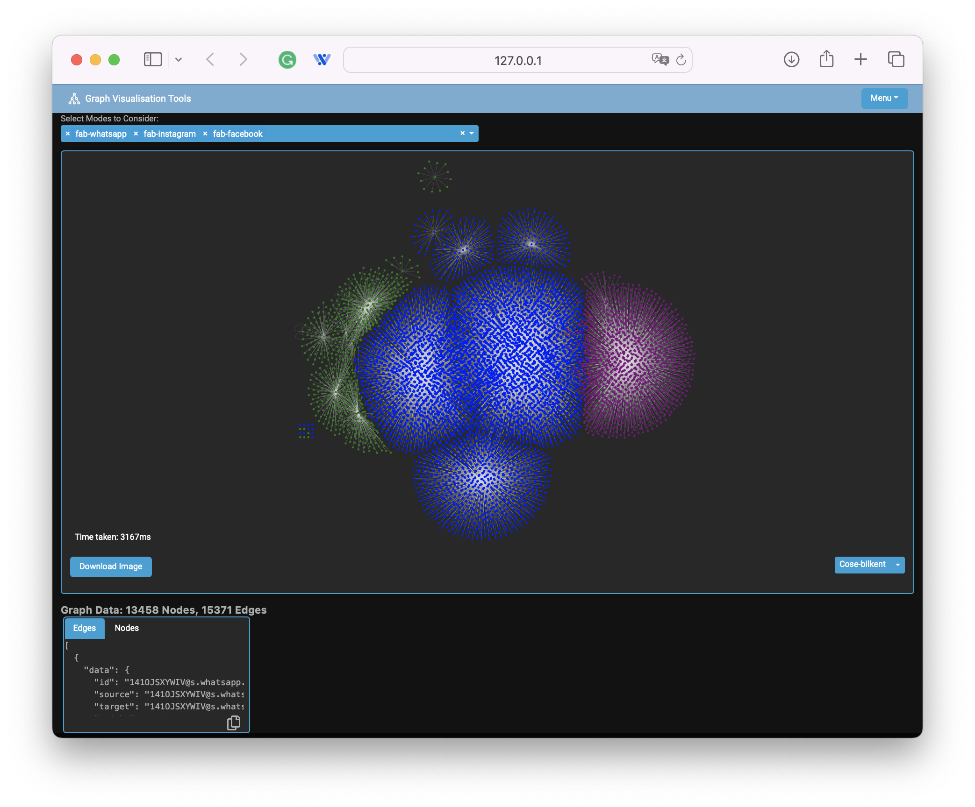hms. Each layout provides a different perspective, helping to uncover various patterns and structures within the data. Note that some layouts might take longer, especially with larger networks.

* **Faster layouts** : Breadthfirst, Circle, Concentric, Grid, Random
* **Slower layouts** : Cose, Cose-bilkent, Cola, Dagre, Klay, Spread

1. Exploring the Graph:

Interact with the graph using the context menus to manipulate nodes and edges. Isolate nodes, change sizes, and mark nodes for further investigation. Select nodes to see their ID. Below is an example use of node isolation.

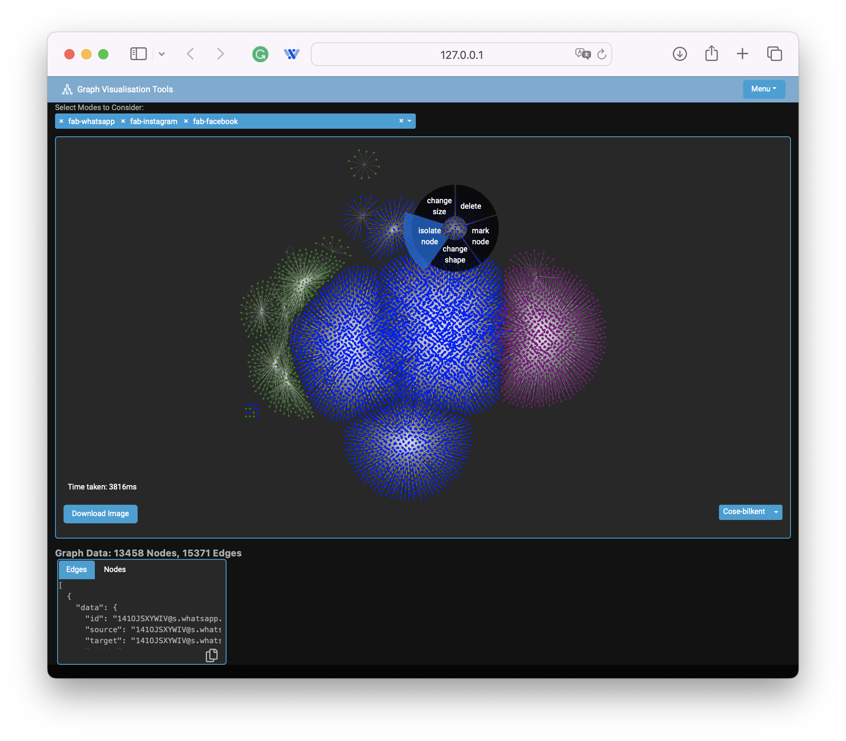

Before isolating node using context menu

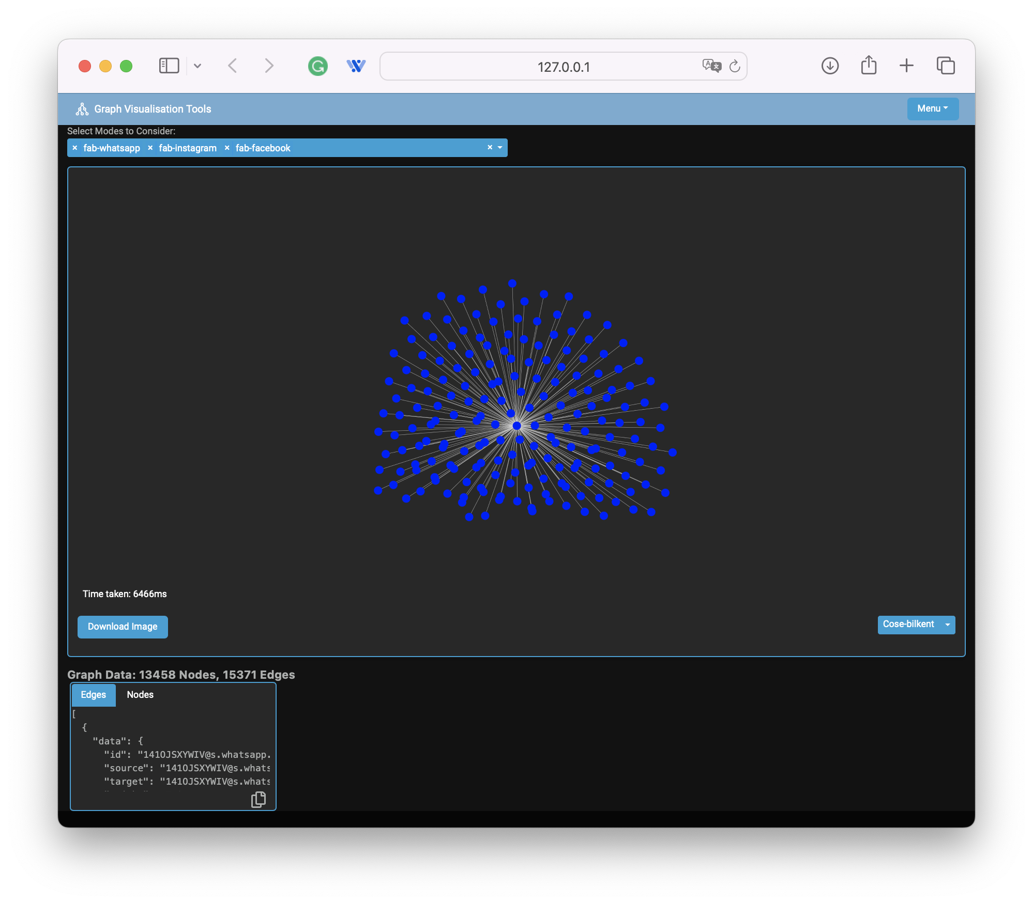

After isolating node using context menu